**RAID (redundant array of independent disks)**

RAID (redundant array of independent disks; originally redundant array of inexpensive disks) provides a way of storing the same data in different places (thus, [redundantly](http://searchstorage.techtarget.com/definition/redundant)) on multiple [hard disks](http://searchstorage.techtarget.com/definition/hard-disk) (though not all RAID levels provide [redundancy](http://whatis.techtarget.com/definition/redundancy)). By placing data on multiple disks, input/output ([I/O](http://searchcio-midmarket.techtarget.com/definition/input-output)) operations can overlap in a balanced way, improving performance. Since multiple disks increase the mean time between failures ([MTBF](http://whatis.techtarget.com/definition/MTBF-mean-time-between-failures)), storing data redundantly also increases [fault tolerance](http://searchcio-midmarket.techtarget.com/definition/fault-tolerant).

AID arrays appear to the operating system ([OS](http://whatis.techtarget.com/definition/operating-system-OS)) as a single logical hard disk. RAID employs the technique of [disk mirroring](http://searchstorage.techtarget.com/definition/disk-mirroring) or [disk striping](http://searchstorage.techtarget.com/definition/disk-striping), which involves [partitioning](http://searchstorage.techtarget.com/definition/partition) each drive's storage space into units ranging from a [sector](http://searchstorage.techtarget.com/definition/sector) (512 [bytes](http://searchstorage.techtarget.com/definition/byte)) up to several [megabytes](http://searchstorage.techtarget.com/definition/megabyte). The stripes of all the disks are interleaved and addressed in order.

In a single-user system where large [records](http://searchoracle.techtarget.com/definition/record), such as medical or other scientific images, are stored, the stripes are typically set up to be small (perhaps 512 bytes) so that a single record spans all disks and can be accessed quickly by reading all disks at the same time.

In a multi-user system, better performance requires establishing a stripe wide enough to hold the typical or maximum size record. This allows overlapped disk I/O across drives.

***Four levels of RAIDs.***

RAID 0

* RAID 1
* RAID 5
* RAID 10 (also known as RAID 1+0)

In all the diagrams mentioned below:

i.A, B, C, D, E and F – represents blocks

ii. p1, p2, and p3 – represents parity

RAID LEVEL 0

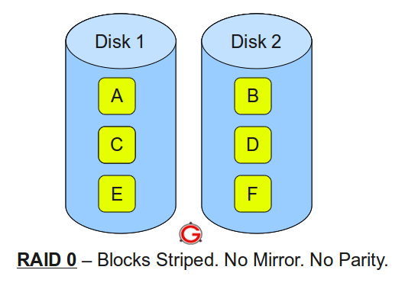

Following are the key points to remember for RAID level 0.

* Minimum 2 disks.
* Excellent performance ( as blocks are striped ).
* No redundancy ( no mirror, no parity ).
* Don’t use this for any critical system.

### RAID LEVEL 1

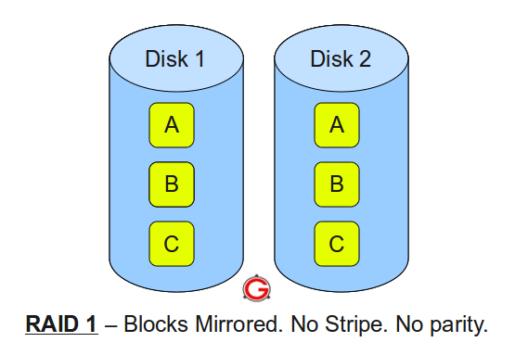

Following are the key points to remember for RAID level 1.

* Minimum 2 disks.
* Good performance ( no striping. no parity ).
* Excellent redundancy ( as blocks are mirrored ).

### RAID LEVEL 5

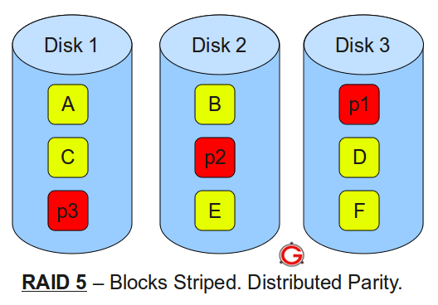  
Following are the key points to remember for RAID level 5.

* Minimum 3 disks.
* Good performance ( as blocks are striped ).
* Good redundancy ( distributed parity ).
* Best cost effective option providing both performance and redundancy. Use this for DB that is heavily read oriented. Write operations will be slow.

### RAID LEVEL 10

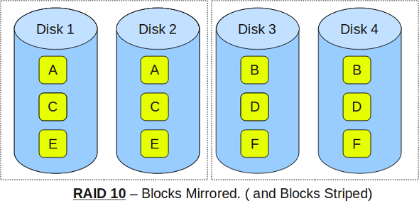

Following are the key points to remember for RAID level 10.

1. Minimum 4 disks.

2. This is also called as “stripe of mirrors”

3.Excellent redundancy ( as blocks are mirrored )

4.Excellent performance ( as blocks are striped )

**RS 232**

In [telecommunications](https://en.wikipedia.org/wiki/Telecommunications), RS-232 is a [standard](https://en.wikipedia.org/wiki/Technical_standard) for [serial communication](https://en.wikipedia.org/wiki/Serial_communication) transmission of data. It formally defines the signals connecting between a DTE ([data terminal equipment](https://en.wikipedia.org/wiki/Data_terminal_equipment)) such as a [computer terminal](https://en.wikipedia.org/wiki/Computer_terminal), and a DCE ([data circuit-terminating equipment](https://en.wikipedia.org/wiki/Data_circuit-terminating_equipment) or [data communication equipment](https://en.wikipedia.org/wiki/Data_communication_equipment)), such as a [modem](https://en.wikipedia.org/wiki/Modem). The RS-232 standard is commonly used in [computer](https://en.wikipedia.org/wiki/Computer) [serial ports](https://en.wikipedia.org/wiki/Serial_port). The standard defines the electrical characteristics and timing of signals, the meaning of signals, and the physical size and [pinout](https://en.wikipedia.org/wiki/Pinout" \o "Pinout) of connectors.

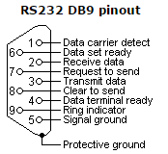 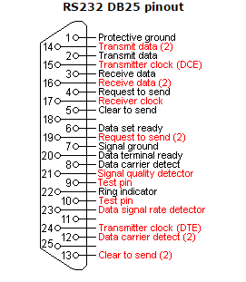

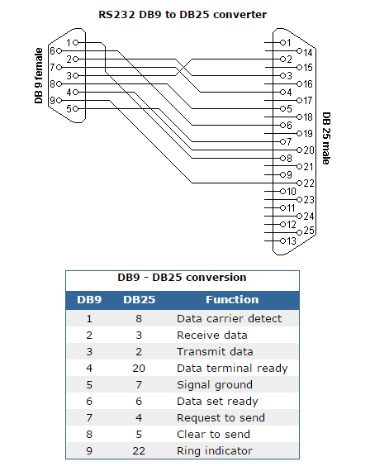

# *Server in Computer Neworking*

A server is a computer designed to process requests and deliver data to other (client) computers over a local network or the internet. Although any computer running special software can function as a server, the most typical use of the word references the very large, high-powered machines that function as the pumps pushing and pulling data across the internet.

Most computer networks support one or more servers that handle specialized tasks.

As a rule, the larger the network—in terms of clients that connect to it or the amount of data that it moves—the more likely it is that several servers play a role, each dedicated to a specific purpose.

Strictly speaking, the server is the software that handles a task. However, the powerful hardware that supports this software is also usually called a server because server software coordinating a network of hundreds or thousands of clients requires hardware much more robust than what you'd buy for ordinary consumer use.

### Common Types of Servers

A large, general-purpose network supporting a medium-sized company will likely deploy several different types of servers:

* [Web servers](https://www.lifewire.com/web-browsers-and-web-servers-communicate-817764), to show pages and run apps in connecting Web browsers
* Email servers, to facilitate the sending and receiving of messages
* FTP servers, to support the moving of files through [File Transfer Protocol](https://www.lifewire.com/file-transfer-protocol-817943) tools
* Identity servers, to support logins and security roles for authorized users

Hundreds of different types of specialized server types support computer networks. Apart from the common corporate types, home users often interface with online game servers, chat servers and even streaming-audio services.

### Network Server Types

Many networks on the internet employ a [client-server](https://www.lifewire.com/operating-systems-unix-vs-windows-2180225) networking model integrating websites and communication services.

An alternative model—[peer-to-peer networking](https://www.lifewire.com/operating-systems-unix-vs-windows-2180225)—allows all devices on a network to function as either a server or client as needed. Peer networks offer a greater degree of privacy because communication between computers is more targeted, but most implementations of peer-to-peer networking aren't robust enough to support very large traffic spikes.

Features of network servers:

* Computers are provided with more memory and storage capacity and also are configured to do additional processing to handle the different client requests.
* Machines are usually high performing personal computers with reliable and fast hard disks, powerful processors and high amounts of available RAM.
* Can also act as a central file storage unit. This can prevent data being stored in different workstations in the network.
* Authentication and user control can be set on another workstation using a network server.
* Security control measures can be more convenient to manage using a network server.
* Network server is also capable of running an intranet.
* Some of the common examples of network servers are FTP servers and web servers.

Workstation

A name given to a single computer that is connected to another computer or [network](http://www.computerhope.com/jargon/n/network.htm). A workstation has no important function and is not a necessity for a network to operate. A workstation is only needed for a single user to connect to the network.

### Unicast , Multicast and Broadcast Address

### Unicast

Unicast is a type of communication where data is sent from one computer to another computer.

In Unicast type of communication, there is only one sender, and one receiver.

Example:

1) Browsing a website. (Webserver is the sender and your computer is the receiver.)

2) Downloading a file from a FTP Server. (FTP Server is the sender and your computer is the receiver.)

**Multicast**

Multicast is a type of communication where multicast traffic addressed for a group of devices on the network. IP multicast traffic are sent to a group and only members of that group receive and/or process the Multicast traffic.

Devices which are interested in a particular Multicast traffic must join to that Multicast group to receive the traffic. IP Multicast Groups are identified by Multicast IP Addresses (IPv4 Class D Addresses)

In Multicast, the sender transmit only one copy of data and it is delivered and/or processed to many devices (Not as delivered and processed by all devices as in Broadcast) who are interested in that traffic.

Example : Multicast Windows Deployment Services (WDS) OS deployment traffic, IP TV etc

**Broadcast**

Broadcast is a type of communication where data is sent from one computer once and a copy of that data will be forwarded to all the devices.

In Broadcast, there is only one sender and the data is sent only once. But the Broadcast data is delivered to all connected devices.

Switches by design will forward the broadcast traffic and Routers by design will drop the broadcast traffic. In other words, Routers will not allow a broadcast from one LAN to cross the Router and reach another Network Segment. The primary function of a Router is to divide a big Broadcast domain to Multiple smaller Broadcast domain.

Example: ARP Request message, DHCP DISCOVER Message